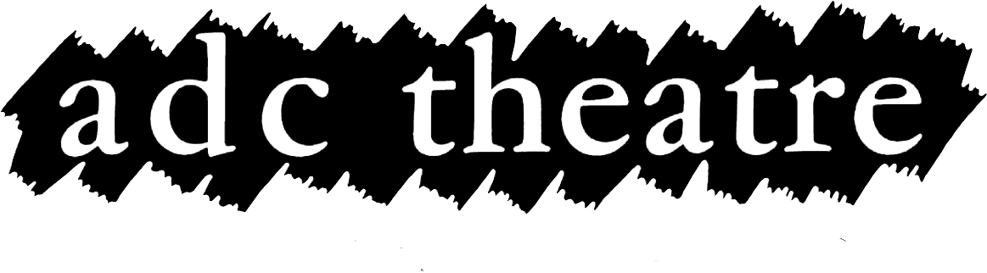
Children Under-16

You have indicated that your production will include children under the age of 16, performing on stage. Please complete and return the following form, and provide the Theatre with any required documentation.

Licence
Depending on the circumstances of your production any children appearing may need a license from the Cambridge County Council, please see their guidance for more information: http://www.cambridgeshire.gov.uk/childrenandfamilies/workandtraining/childrenandwork/childreninentertainment.htm

The ADC Theatre needs to have copies of any licenses issued, or in a case where a licence is not required, a copy of the EXEMPTION LICENSE.

Chaperone
“If a parent/carer does not accompany a child the production company is required to supply a chaperone who is currently licensed by the Local Authority in which he/she lives.”

Please give the name and contact details of the parent/carer or chaperone that will accompany the children while in the Theatre, please also supply a copy of the chaperone’s licence.

Child Name:

Chaperone Name:

Chaperone mobile number:

Exit Time
Children cannot stay in the Theatre beyond 10 pm (under 13), and 10.30pm (over 13), and therefore, unless the show finishes before this time, cannot participate in the curtain call.

What time will the child leave the Theatre every night? __________

Changing Rooms
Children require separate dressing room facilities to adults and girls and boys cannot share a dressing room. Normally, the whole company of a production would share a dressing room at the ADC.

What arrangements have you made for changing rooms for the children performing?
__________________________________________________________
__________________________________________________________
__________________________________________________________
____________________________________________________________________________________________________________________

If this form, along with any other required information, is not returned to the Production Manager by one week before your performance then the ADC Theatre will not allow children to play a part in your production

Council Contact: Children's Performance & Chaperone Licensing Officer
Wendy Lancaster - 01354 750166 - Wendy.Lancaster@cambridgeshire.gov.uk
More Info: http://www.bucksinfo.net/nncee/entertainment/

